ZOO DATABASE SYSTEM – MYSQL

USER REQUIREMENTS
In a zoo management system, various entities work together to ensure the efficient handling of animals. The Animal entity holds key details such as animal ID, species, name, gender, date of birth, current health status, diet, and arrival date at the zoo. Each animal is housed in a specific Habitat, which includes habitat ID, habitat type (e.g., savannah, rainforest), size, climate, maximum capacity, and status. A habitat can house one or many animals, depending on the species' requirements and behavior. However, a habitat may house no animals if it is under maintenance, undergoing renovations, or specifically designated for a species not currently present in the zoo, ensuring that the habitat is not overcrowded or unsuitable for the animals. Each habitat can accommodate a maximum of 30 animals to ensure adequate space and proper living conditions.

The Zookeeper entity stores the zookeeper ID, name, experience level, assigned habitat, and specialized skill (e.g., working with reptiles or large mammals). Zookeepers are assigned to care for one or more animals, and each animal is cared for by one or multiple zookeepers. The relationship includes attributes such as the date the zookeeper was assigned to the animal and the specific duties, they are responsible for, such as feeding, training, or health monitoring. Each zookeeper can supervise one, none, or more other zookeepers, while a zookeeper may also report to one supervisor. This relationship is characterized by attributes such as supervision start date, supervision end date, and supervision level.

A zookeeper may manage one or no zoo vehicle, with each vehicle assigned to a specific zookeeper; in some cases, a vehicle may not be managed by any zookeeper, such as during maintenance or if the vehicle is temporarily out of service. Each zookeeper is permitted to manage only one vehicle to ensure efficient allocation of resources and prevent the overextension of responsibilities. This limitation helps maintain accountability and ensures that vehicles are properly maintained and available for their designated duties within the zoo. The vehicle entity includes attributes such as vehicle ID, model, status, and plate number.

ENTITY RELATIONSHIP DIAGRAM (ERD)

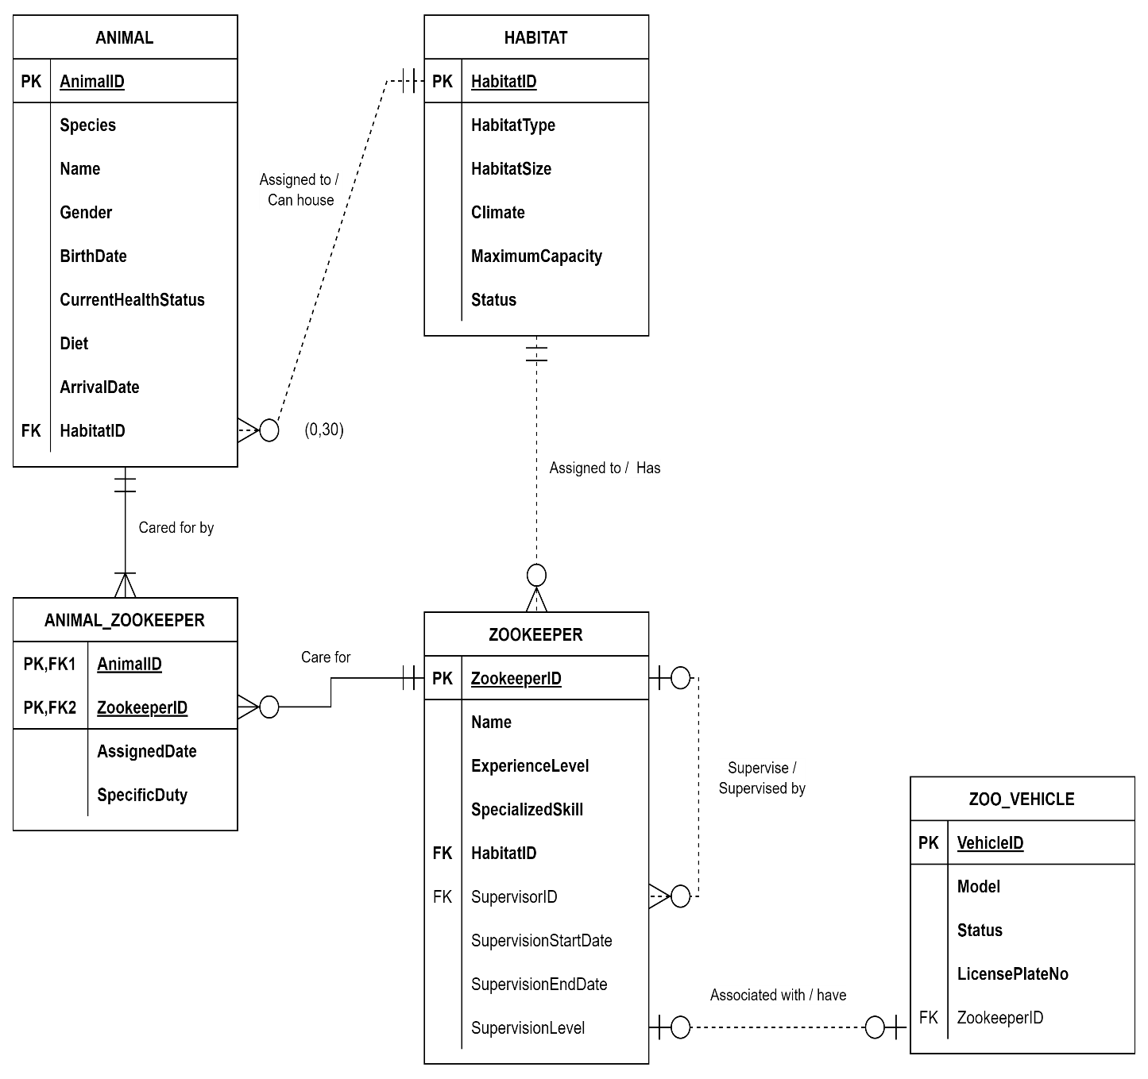

TABLE DATA
HABITAT table
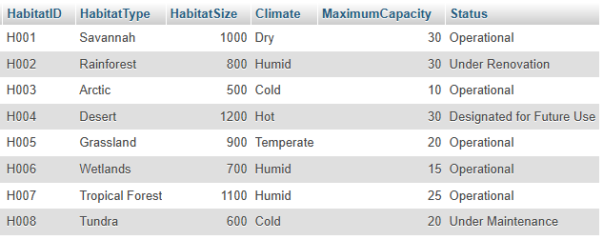
ANIMAL table
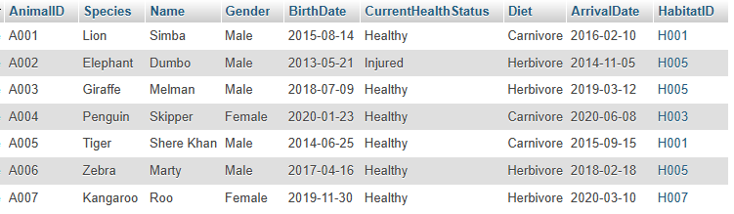
ZOOKEEPER table
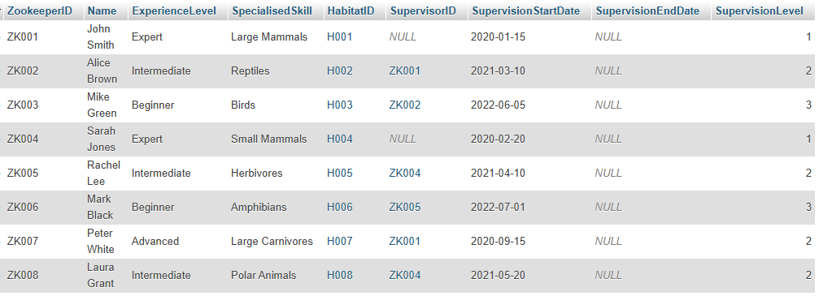

ANIMAL_ ZOOKEEPER table
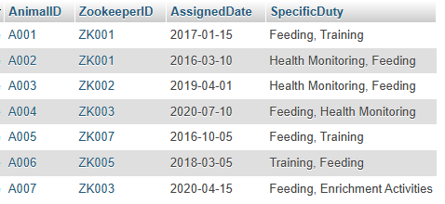
ZOO_VEHICLE table
